INTRODUCTION
The Yocto Project is an open source collaboration project that helps developers create custom linux-based systems for embedded products, regardless of the hardware architecture. For more information, check this link → yoctoproject

REQUIREMENTS OF THE HOST SYSTEM
- It is recommended that at least provide 120Gb memory, which is enough to compile any backend.
- This are the supported Linux Distributions
- Ubuntu 14.10
- Ubuntu 15.04
- Ubuntu 15.10
- Ubuntu 16.04 (LTS)
- Fedora release 22
- Fedora release 23
- CentOS release 7.x
- Debian GNU/Linux 8.x (Jessie)
- Debian GNU/Linux 9.x (Stretch)
- openSUSE 13.2
- openSUSE 42.1
Note
The "Linux mint" which we are using at «STAUBLI» is not officially supported for Yocto but it works good as well.
- The below are the essential Yocto Project host packages you need to install before you start building the images
$ sudo apt-get install gawk wget git-core diffstat unzip texinfo gcc-multilib build-essential chrpath socat
i.MX layers host packages for a Ubuntu 12.04 or 14.04 host setup
$ sudo apt-get install libsdl1.2-dev xterm sed cvs subversion coreutils texi2html docbook-utils python-pysqlite2 help2man make gcc g++ desktop-file-utils libgl1-mesa-dev libglu1-mesa-dev mercurial autoconf automake groff curl lzop asciidoc

i.MX layers host packages for a Ubuntu 12.04 host setup only
$ sudo apt-get install uboot-mkimage
i.MX layers host packages for a Ubuntu 14.04 host setup only
$ sudo apt-get install u-boot-tools

SETTING-UP THE REPO UTILITY
Repo is a tool built on top of Git that makes it easier to manage projects that contain multiple repositories, which do not need to be on the same server. Repo complements very well the layered nature of the Yocto Project, making it easier for customers to add their own layers to the BSP.

To install the “repo” utility, perform these steps
- Create a bin folder in your home directory
$ cd ~ (This takes you to home directory)
$ mkdir ~/bin (this step may not be needed if the bin folder already exists)
$ curl http://commondatastorage.googleapis.com/git-repo-downloads/repo > ~/bin/repo
$ chmod a+x ~/bin/repo
- Add the following line to the .bashrc file to ensure that the ~/bin folder is in your PATH variable
$ export PATH=~/bin:$PATH

YOCTO PROJECT SETUP AND IMAGE BUILDING
- After setting the repo utility, Create a directory named 'aurora' in the directory /users/stage3/mywork
$ mkdir aurora
$ cd aurora
$ repo init -u https://source.codeaurora.org/external/imx/fsl-arm-yocto-bsp -b imx-morty
$ repo sync
Note
If you get an error during this process, install libcur14-openssl-dev:i386 package
- Setup the build folder by entering the following command
$ MACHINE=imx6dlsabresd DISTRO=fsl-imx-x11 source ./fsl-setup-release.sh -b build
because we are building for imx6 dual-lite sabre SD board

Note
We need to be in /mywork/aurora directory each time we enter the above command and It will direct you automatically to the /mywork/aurora/build directory.
- Edit the aurora/build/conf/local.conf file as follows which place the downloads, sstate-cache and tmp folders in the different location (This is necessary because this folders take lot of memory)
MACHINE ??= 'imx6dlsabresd'
DISTRO ?= 'fsl-imx-x11'
PACKAGE_CLASSES ?= "package_rpm"
EXTRA_IMAGE_FEATURES ?= "debug-tweaks"
USER_CLASSES ?= "buildstats image-mklibs image-prelink"
PATCHRESOLVE = "noop"
BB_DISKMON_DIRS = "\
STOPTASKS,${TMPDIR},1G,100K \
STOPTASKS,${DL_DIR},1G,100K \
STOPTASKS,${SSTATE_DIR},1G,100K \
STOPTASKS,/tmp,100M,100K \
ABORT,${TMPDIR},100M,1K \
ABORT,${DL_DIR},100M,1K \
ABORT,${SSTATE_DIR},100M,1K \
ABORT,/tmp,10M,1K"
PACKAGECONFIG_append_pn-qemu-native = " sdl"
PACKAGECONFIG_append_pn-nativesdk-qemu = " sdl"
CONF_VERSION = "1"

# It is necessary to place in the /home/hdd500Gb to save the memory available on our users/stage3

DL_DIR = "/home/hdd500Gb/aurora/build/downloads/"
SSTATE_DIR = "/home/hdd500Gb/aurora/build/sstate-cache/"
TMPDIR = "/home/hdd500Gb/aurora/build/tmp/"

ACCEPT_FSL_EULA = "1"
- Copy the local.conf to the local.conf.org
$ cp conf/local.conf conf/local.conf.org
This step is mandatory because the «local.conf.org» file replaces the «local.conf» contents each time you try to build an image

- By default boot partition is 8MB but we can increase it to 50MB for example.
To do so, We need to edit the file in the following directory as follows
mywork/aurora/sources/meta-freescale/conf/machine/imx6dlsabresd.conf

#@TYPE: Machine
#@NAME: NXP i.MX6DL SABRE Smart Device
#@SOC: i.MX6DL
#@DESCRIPTION: Machine configuration for NXP i.MX6DL SABRE Smart Device
#@MAINTAINER: Otavio Salvador <otavio@ossystems.com.br>

MACHINEOVERRIDES =. "mx6:mx6dl:"
require conf/machine/include/imx6sabresd-common.inc

KERNEL_DEVICETREE = "imx6dl-sabresd.dtb \
imx6dl-sabresd-ldo.dtb \
imx6dl-sabresd-hdcp.dtb \
imx6dl-sabresd-enetirq.dtb \
imx6dl-sabresd-btwifi.dtb \
"

UBOOT_CONFIG ??= "sd"
UBOOT_CONFIG[sd] = "mx6dlsabresd_config,sdcard"
UBOOT_CONFIG[epdc] = "mx6dlsabresd_epdc_config"
UBOOT_CONFIG[mfgtool] = "mx6dlsabresd_config"
MACHINE_FIRMWARE += "firmware-imx-epdc"

# This parameter is used to set th size of boot partition
BOOT_SPACE += "51200"
- After this We need to bitbaked the image by following command
$ bitbake -v core-image-minimal
We can find various types of bitbake command in this link → Bitbake commands
Notes
- Each time you want to change the «Boot partition» size, You have to enter the command below before bitbaking the image again which cleans the existing build
$ bitbake -c cleanall core-image-minimal
- When you get errors during build, Check NXP forums for the solutions
- Make sure that you have "make" version 4.1 or above in the linux machine you are building
- After the end of the building, We can find the images in the below directory
/home/hdd500Gb/aurora/build/tmp/deploy/images/imx6dlsabresd

FLASHING THE BUILT IMAGE INTO THE SDCARD
- Open the terminal in the location /home/hdd500Gb/aurora/tmp/deploy/images/imx6dlsabresd
- To know the address of the inserted sdcard, enter following command
$ cat /proc/partitions
You have inserted SDcard in /dev/sdc
Note
Please be careful at the inserted sdcard directory i.e. of=/dev/sdc
- I have flashed the built image into the sdcard by following command
$ sudo dd if=core-image-minimal-imx6dlsabresd.sdcard of=/dev/sdc bs=1M conv=fsync
Enter the your password and it will take 5-7 minutes
$ sync
$ sync
Note
Afterwards takeout the sdcard (No need to eject it) and insert it into slot provided in the IMX6DLSABRESD eval board and Power it up.

ADAPTING THE BUILT IMAGE TO THE UNICPU
In order to adapt to SDcard to your unicpu (customized staubli board),
- Firstly, you have to flash the image created by yocto into SDcard
- You have to create our customized kernel image (uImage) and modules
- You have to create the «u-boot-with-spl.imx» and «boot_unicpu.scr»

Build the kernel (uImage and Modules) from staubli source code
- Download the source code in the directory /users/stage3/mywork by following command
$ git clone git://fav10lin.staubli.pri/linux-2.6-imx.git
- Change the cloned directory name to "linux-imx" and assign the remote name as follows
$ git remote add aurora https://source.codeaurora.org/external/imx/linux-imx
- Fetch and checkout to lastest aurora branch with following command
$ git fetch aurora
$ git branch -a
$ git checkout aurora/imx_4.9.11_1.0.0_ga
- The next task is to build the cross compiler tools, To do it first of all create an empty directory named as "Tools" in the following directory
/home/hdd500Gb/Tools/meta-toolchain
- Go to /users/stage3/mywork/aurora and enter following commands
$ MACHINE=imx6dlsabresd DISTRO=fsl-imx-x11 source ./fsl-setup-release.sh -b build
$ bitbake meta-toolchain
- The above procedure will produce a directory "sdk" in the home/hdd500Gb/aurora/build/tmp/deploy/sdk
- Open the sdk directory and click on "fsl-imx-x11-glibc-x86_64-meta-toolchain-cortexa9hf-neon-toolchain-4.9.11-1.0.0.sh"; this leads to a terminal asking you a path to install the compiler tools give the path as /home/hdd500Gb/Tools/meta-toolchain and continue the installation. This procedure produces a toolchain which can be used to build kernel.
- Now, You can start building the kernel. Firstly set the environment varaibles, enter the following commands
$ cd /users/stage3/mywork/linux-imx
$ source /home/hdd500Gb/Tools/environment-setup-cortexa9hf-neon-poky-linux-gnueabi
this will automatically set all the needed required parameters
Note
This above step should be repeated when ever you want to perform some changes to kernel
- We have to enable the touch on UNICPU, The procedure for that is as follows
- Acquire and add the "egalax_i2c.c" file to directory
/users/stage3/mywork/linux-imx/drivers/input/touchscreen
- Add the following lines to the "Kconfig" file in the directory /users/stage3/mywork /linux-imx/drivers/input/touchscreen
# Added Egalax i2c driver
config TOUCHSCREEN_EGALAX_I2C
tristate "EETI eGalax i2c multi-touch panel support"
depends on I2C && OF
help
Say Y here to enable support for I2C connected EETI
eGalax multi-touch panels.
To compile this driver as a module, choose M here: the
module will be called egalax_i2c.
- Add the following line to the "Makefile" file in the following directory /home/hdd500Gb/linux-imx/drivers/input/touchscreen
#Added Egalax i2c Driver
obj-$(CONFIG_TOUCHSCREEN_EGALAX_I2C)+= egalax_i2c.o
- Now you can configure the kernel by using menuconfig by which you can choose what are the configurations needed to build your uImage
$ make menuconfig
sometimes if you don’t find the added driver option, use the below command instead
$ make ARCH=arm menuconfig
Note
Before entering the above command please make sure to install the libncurses5-dev and libncursesw5-dev packages in our host system by following command
$ sudo apt-get install libncurses5-dev libncursesw5-dev

Procedure for enabling Touch
In the menuconfig window, Press « m » for

Device Drivers → Input device support → Touchscreens → EETI eGalax i2c multi-touch panel support

Procedure for enabling USB
In the menuconfig window, press « y » for
Device Drivers → HID support → Generic HID driver
(This enables the USB mouse and you may need to type « usb start » command in uboot after starting the kernel)
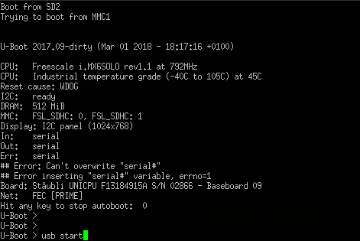

After this save the settings and exit the window
- To build the kernel, use the make command and the load address of processor being used i.e For i.MX6Quad and Dual, LOADADDR = 0x10008000
$ make uImage LOADADDR=0x10008000
this might take some time to build and after finishing, the output is located in the following directory /users/stage3/mywork/linux-imx/arch/arm/boot
- The above step results only uImage file but to build the kernel modules, use following command
$ make modules
it will take some time to build, after that install them by using following command
$ make modules_install INSTALL_MOD_PATH=/users/stage3/mywork/Installed_modules
- In order to build the dtb files
$ cd /users/stage3/mywork/linux-imx
$ source /home/hdd500Gb/Tools/environment-setup-cortexa9hf-neon-poky-linux-gnueabi
Note
- Please make sure that device-tree-complier package is installed in your linux machine before running the below commands.
- To enable the Touch, make sure to add the following lines to
linux-imx/arch/arm/boot/dts/imx6qdl-unicpu-faverges.dtsi
&i2c1 {
clock-frequency = <400000>;
pinctrl-names = "default";
pinctrl-0 = <&pinctrl_i2c1>;
status = "okay";

egalax_i2c@2a {
compatible = "eeti,egalax_i2c";
reg = <0x2a>;
interrupt-parent = <&gpio6>;
interrupts = <8 8>;
int-gpios = <&gpio6 8 0>;
};
};
- To enable Ethernet, make sure to add the following block into the
linux-imx/arch/arm/boot/dts/imx6qdl-unicpu.dtsi/

&clks {
assigned-clocks = <&clks IMX6QDL_CLK_ENET_REF>;
assigned-clock-rates = <50000000>;
};

&fec {
pinctrl-names = "default";
pinctrl-0 = <&pinctrl_enet>;
// phy-connection-type = "rmii";
phy-mode = "rmii";
phy-reset-gpios = <&gpio7 7 0>;
phy-reset-duration = <2>;
// clocks = <&clks IMX6QDL_CLK_ENET>, <&clks IMX6QDL_CLK_ENET>, <&rmii_clk>;
status = "okay";
};
Enter the following command to generate the dtb file
$ make imx6dl-unicpu-fav1024768.dtb
- Remove the existing zImage, copy the created uImage and dtb file in the «Boot partition» and created modules to «rootfs» partition of the SDcard

uImage from /users/stage3/mywork/linux-imx/arch/arm/boot
dtb files from /users/stage3/mywork/linux-imx/arch/arm/boot/dts
Modules from /users/stage3/mywork/Installed_modules

- Create a text file «boot_unicpu_fdt_sd_nodhcp»
# U-boot script sur carte SD - avec dtb
#
# Boot a Linux kernel from the SD card. The scipt and the uImage are located
# in the first partition of the SD card. It is a DOS partition.
# Screens: 800x600 FAV-LDB-SVGA, 1024x768 SAR-LDB-XVGA

setenv loadaddr 10800000
setenv dtaddr 12000000
setenv mmcdev 0

# Root pour le noyau: mmcblk1p2 pour SD
setenv rootdev /dev/mmcblk1p2

if test $baseboard_id -eq 20 ; then
setenv dtfile imx6dl-unicpu-sar800600.dtb
else
if test $x -eq 800 ; then
setenv dtfile imx6dl-unicpu-fav800600.dtb
else
setenv dtfile imx6dl-unicpu-fav1024768.dtb
fi
fi

# Argument du noyau
setenv bootargs "console=ttymxc0,115200 root=$rootdev rootwait=1"

if load mmc $mmcdev:1 $loadaddr uImage ; then
if load mmc $mmcdev:1 $dtaddr $dtfile ; then
bootm $loadaddr - $dtaddr
fi
fi
- Build «boot_unicpu.scr» file by following command
$ mkimage -T script -A ARM -d boot_unicpu_fdt_sd_nodhcp boot_unicpu.scr
- Copy the created boot_unicpu.scr file to the «Boot partition» of SDcard
- Acquire and Flash the "u-boot-with-spl.imx" file by using following command
$ sudo dd if=u-boot-with-spl.imx of=/dev/sdc bs=1k seek=1 conv=fsync
$ sync
$ sync
Remove the SDcard without ejecting it. There you go your SDcard is ready which can boot-up the STAUBLI customized «UNICPU»
- For enabling the Touch, enter the following commands after the login prompt which loads the egalax driver manually
$ root
$ cd /lib/modules/4.9.11-03209-gc27010d-dirty/kernel/drivers/input/touchscreen
$ insmod egalax_i2c.ko
this will install the egalax i2c driver.
- You can verify the ethernet is working by using the following command
$ ifconfig
These are essential steps to adapt the SDcard to our UNICPU board.

TRANSFERING FILES BETWEEN HOST AND TARGET
We can also transfer files between host and target by using SSH
- After enabling the Ethernet, Use the following command to get into connected UNICPU board through ethernet
$ ssh root@imx6dlsabresd
After,Press "yes" so that the unicpu board is permanently added to your list of known hosts.
- Use the following command to see the available folders in the UNICPU board
$ ls /dev
- Open another terminal and use this following command to copy any files from your PC to host
$ scp <source address> <host user name ex:root@imx6dlsabresd>:> Ex: /dev/mem>
example
$ scp /pdf/permanent/composants/freescale/IMX6/ root@imx6dlsabresd:/dev/null
- Use the following command to copy from host to your PC
$ scp <host user name ex:root@imx6dlsabresd>:<source address Ex: /dev/mem> <Destination address>

ADDING A QT APPLICATION
Qt is much more than just a cross-platform SDK - it's a technology strategy that lets you quickly and cost-effectively design, develop, deploy, and maintain software while delivering a seamless user experience across all devices. For more information click the following link → www.qt.io

For building a QT application on the target, We need two things
- Meta-toolchain-qt5
- QT creator

Procedure to build toolchain for QT from yocto
- Open the terminal in the directory /users/stage3/mywork/aurora
- Enter the following commands
$ MACHINE=imx6dlsabresd DISTRO=fsl-imx-x11 source ./fsl-setup-release.sh -b build
- Bitbake the toolchain by following command
$ bitbake meta-toolchain-qt5
- Open the terminal in /home/hdd500Gb/aurora/build/tmp/deploy/sdk
- open the « fsl-imx-x11-glibc-x86_64-meta-toolchain-qt5-cortexa9hf-neon-toolchain-4.9.11-1.0.0.sh »
- Enter the following location to install /home/hdd500Gb/Tools/meta-toolchain-qt5/ and continue the installation process.
Hence we have build the toolchain for QT5.

Procedure to download and setup Qtcreator
- Download and Install the lastest qtcreator from the www.qt.io/download-open-source
- Make sure to select « QT 5,8 » in the installation process in « Select components step »
- Open the terminal and enter the following command
$ source /home/hdd500Gb/Tools/meta-toolchain-qt5/environment-setup-cortexa9hf-neon-poky-linux-gnueabi
$ cd /home/hdd500Gb/qtcreator/Tools/QtCreator/bin
$ ./qtcreator.sh
This opens the Qtcreator.
- Edit the file in /home/hdd500Gb/Tools/meta-toolchain-qt5/sysroots/cortexa7hf-neon-poky-linux-gnueabi/usr/lib/qt5/mkspecs/linux-arm-gnueabi-g++/qmake.conf
as follows
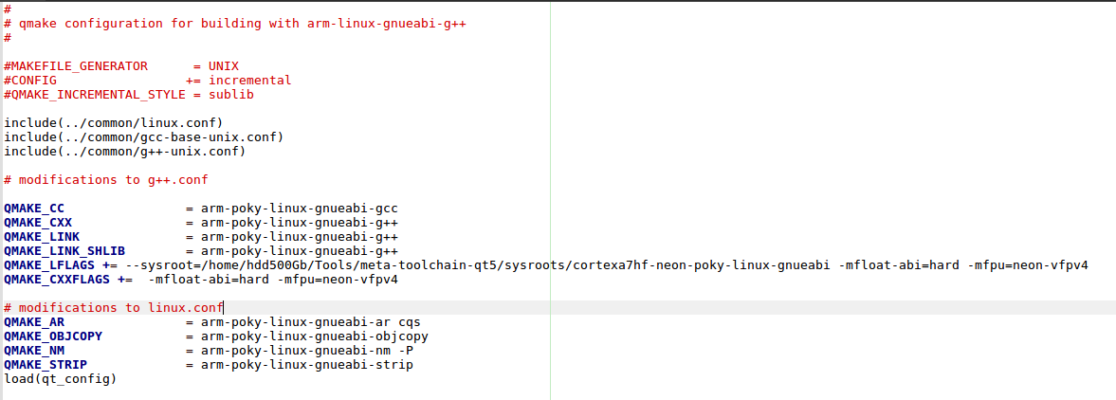
- In the Qtcreator, follow the procedure for configuring the kits for the compilation and debugging
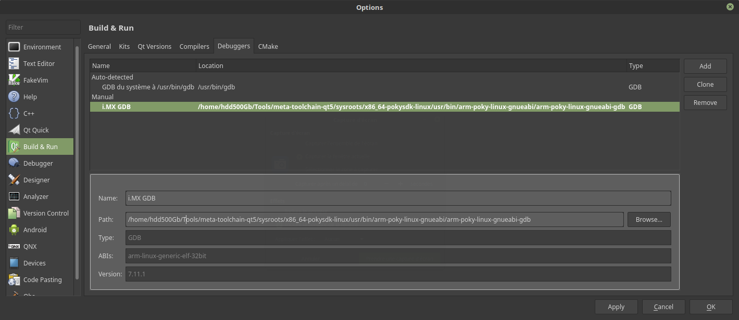
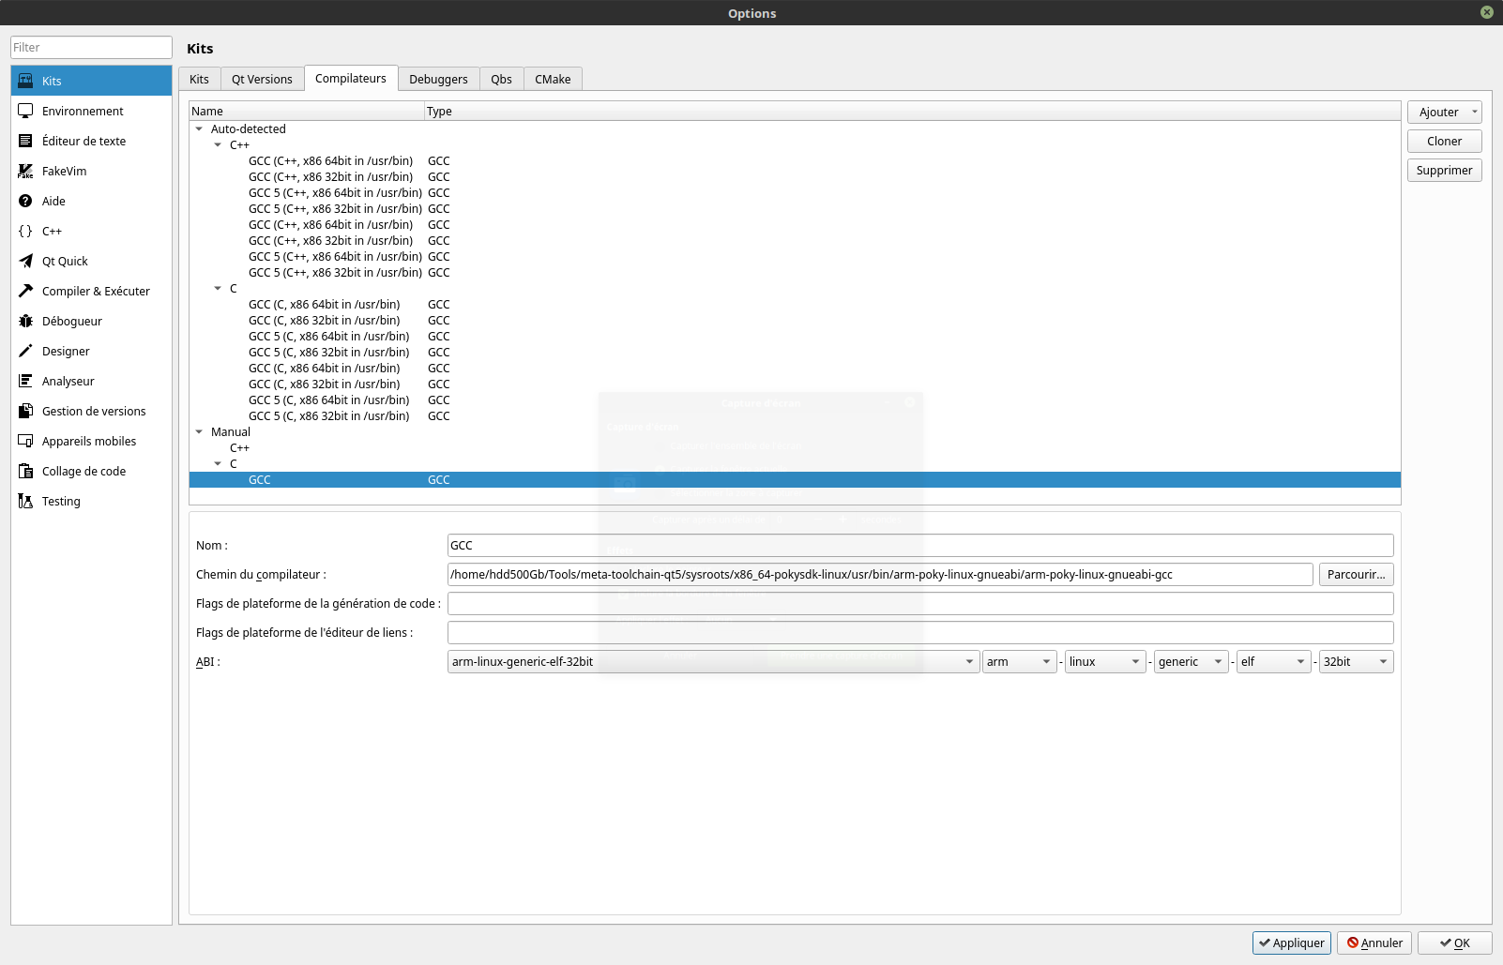
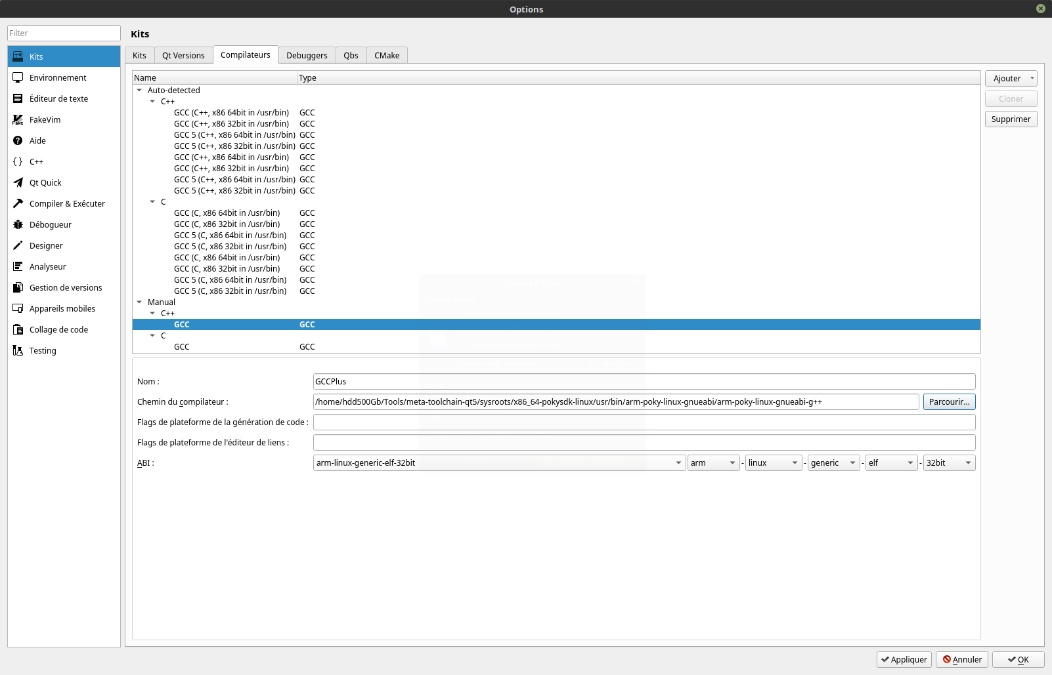
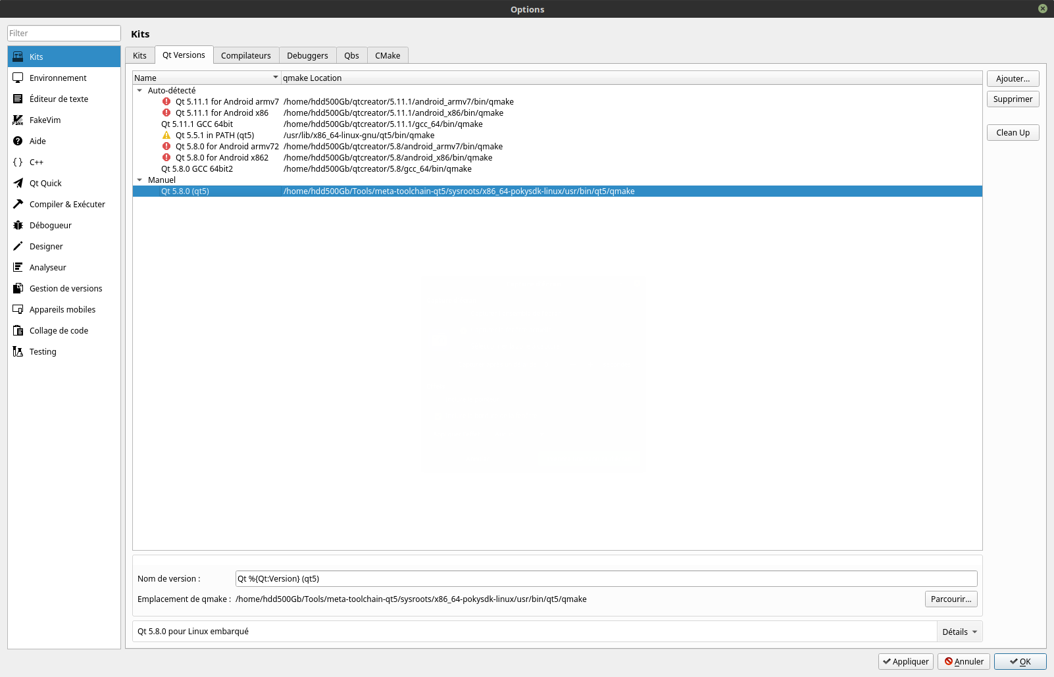

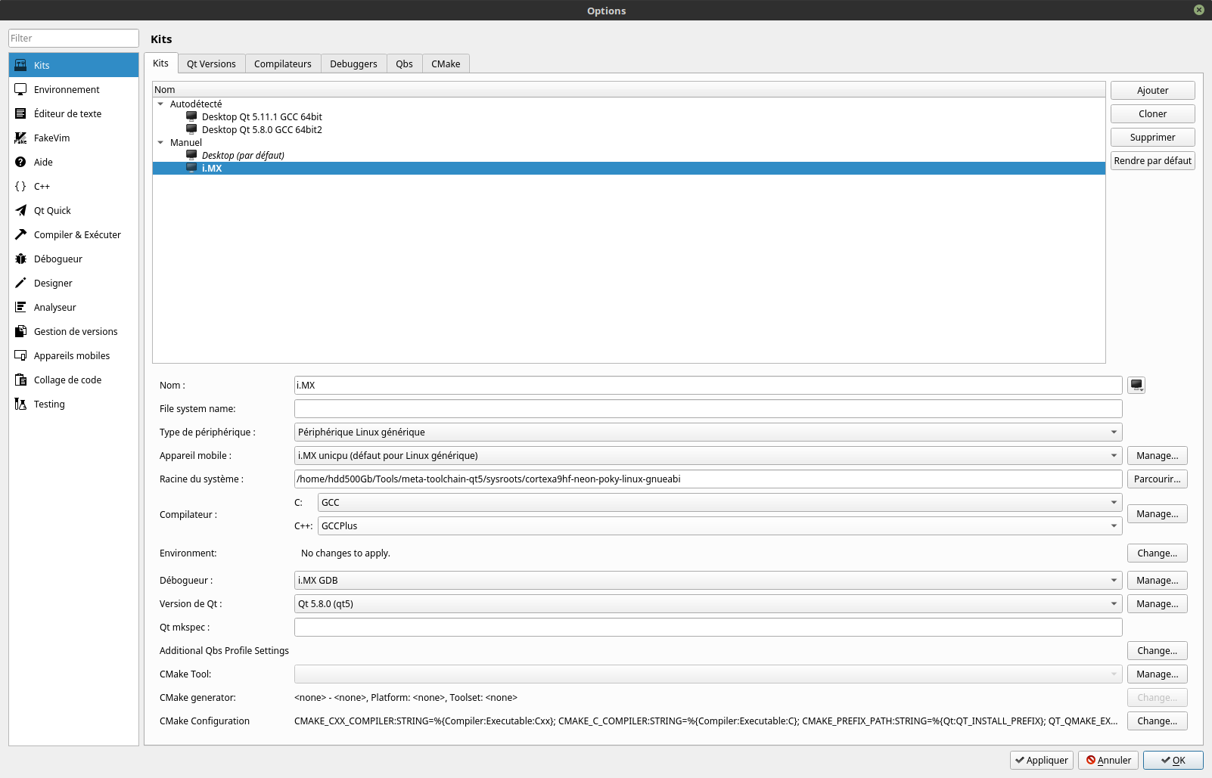
Apply all the changes and press ok. You are ready to use Qt creator.

« Helloworld » QT application writing and compiliation
- Follow the below procedure
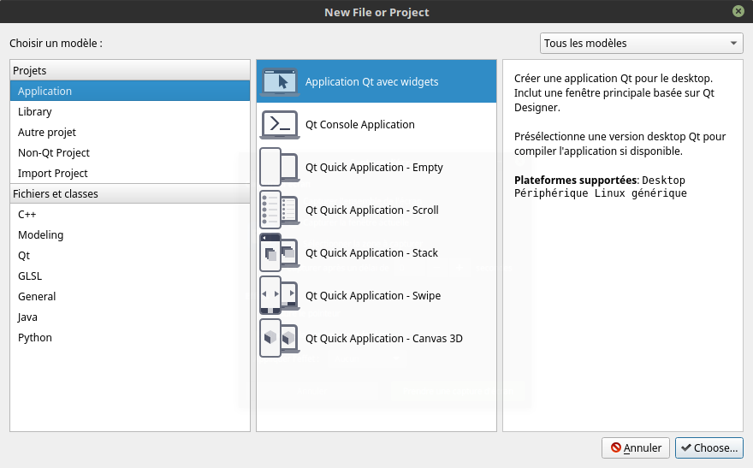
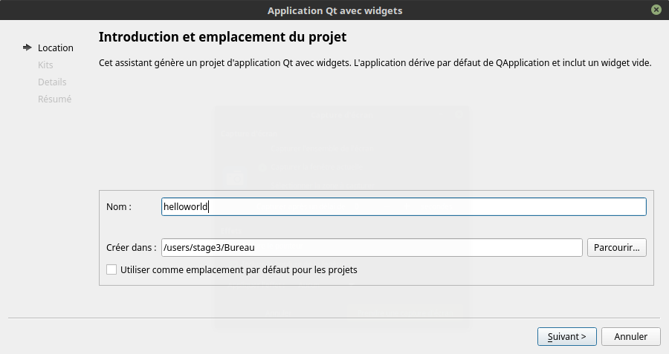
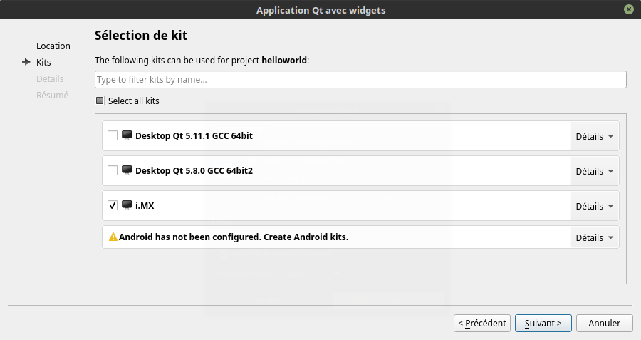

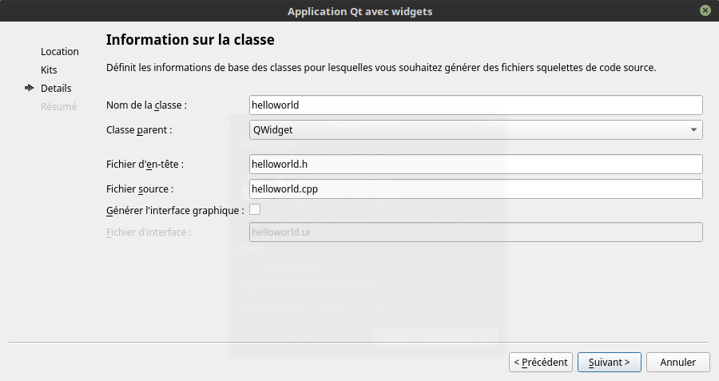
For writing the code for helloworld, follow the link below
https://www.youtube.com/watch?v=wsv11PlqRv0

Integrating the helloworld QT application into Yocto
- Write the code of helloworld.cpp as
#include <QtWidgets/QApplication>
#include <QtWidgets/QPushButton>
int main( int argc, char **argv ) {
QApplication a( argc, argv );
QPushButton hello( "Hello world!", 0 );
hello.resize( 100, 30 );
hello.show();
return a.exec();
}
- Make sure the code of helloworld.pro as
QT += core gui
QT += widgets
QT += quick
CONFIG += c++11

# The following define makes your compiler emit warnings if you use
# any feature of Qt which as been marked deprecated (the exact warnings
# depend on your compiler). Please consult the documentation of the
# deprecated API in order to know how to port your code away from it.
DEFINES += QT_DEPRECATED_WARNINGS

# You can also make your code fail to compile if you use deprecated APIs.
# In order to do so, uncomment the following line.
# You can also select to disable deprecated APIs only up to a certain version of Qt.
#DEFINES += QT_DISABLE_DEPRECATED_BEFORE=0x060000 # disables all the APIs deprecated before Qt 6.0.0

SOURCES += \
helloworldqt5.cpp

#RESOURCES +=

# Default rules for deployment.
#qnx: target.path = /tmp/$${TARGET}/bin
#else: unix:!android: target.path = /opt/$${TARGET}/bin
#!isEmpty(target.path): INSTALLS += target
- Write the helloworld_0,1.bb as
#
# This file was derived from the 'Hello World!' example recipe in the
# Yocto Project Development Manual.
#

SUMMARY = "Simple helloworld application"
SECTION = "examples"
LICENSE = "MIT"
LIC_FILES_CHKSUM = "file://${COMMON_LICENSE_DIR}/MIT;md5=0835ade698e0bcf8506ecda2f7b4f302"

SRC_URI = "file://helloworldqt5.pro \
file://helloworldqt5.cpp \
"
DEPENDS +="qtbase fontconfig"

S = "${WORKDIR}"

inherit qmake5

do_install() {
install -d ${D}${bindir}
install -m 0755 helloworldqt5 ${D}${bindir}
}
- Now add the line IMAGE_INSTALL_append = "helloworldqt5" in the /users/stage3/mywork/aurora/build/conf/local.conf.org
- Open the terminal in the /users/stage3/mywork/aurora
and rebuild the entire core-image-minimal.
Hence we have sucessfully added our customized QT application to the yocto.

OPTIMIZATION OF BOOT TIME

